1. Code :

replace_all([],_,_,[]).

replace_all([X|Y],A,B,[B|Result]) :-

X=A,

replace_all(Y,A,B,Result).

replace_all([X|Y],A,B,[X|Result]) :-

replace_all(Y,A,B,Result).

Output :

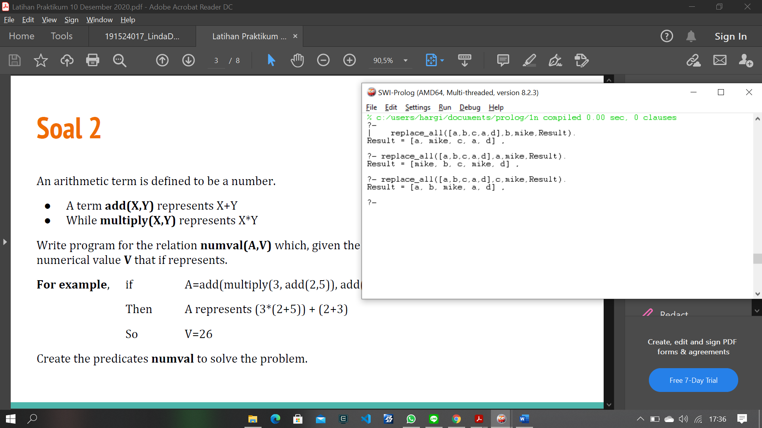

1. Source :

numval(multiply(X,Y),Z):-

numval(X,I),

numval(Y,K),

Z is I*K.

numval(add(X,Y),Z):-

numval(X,I),

numval(Y,K),

Z is I+K.

numval(X,X):-

number(X).

numval(X,X,X):-

number(X).

Output:

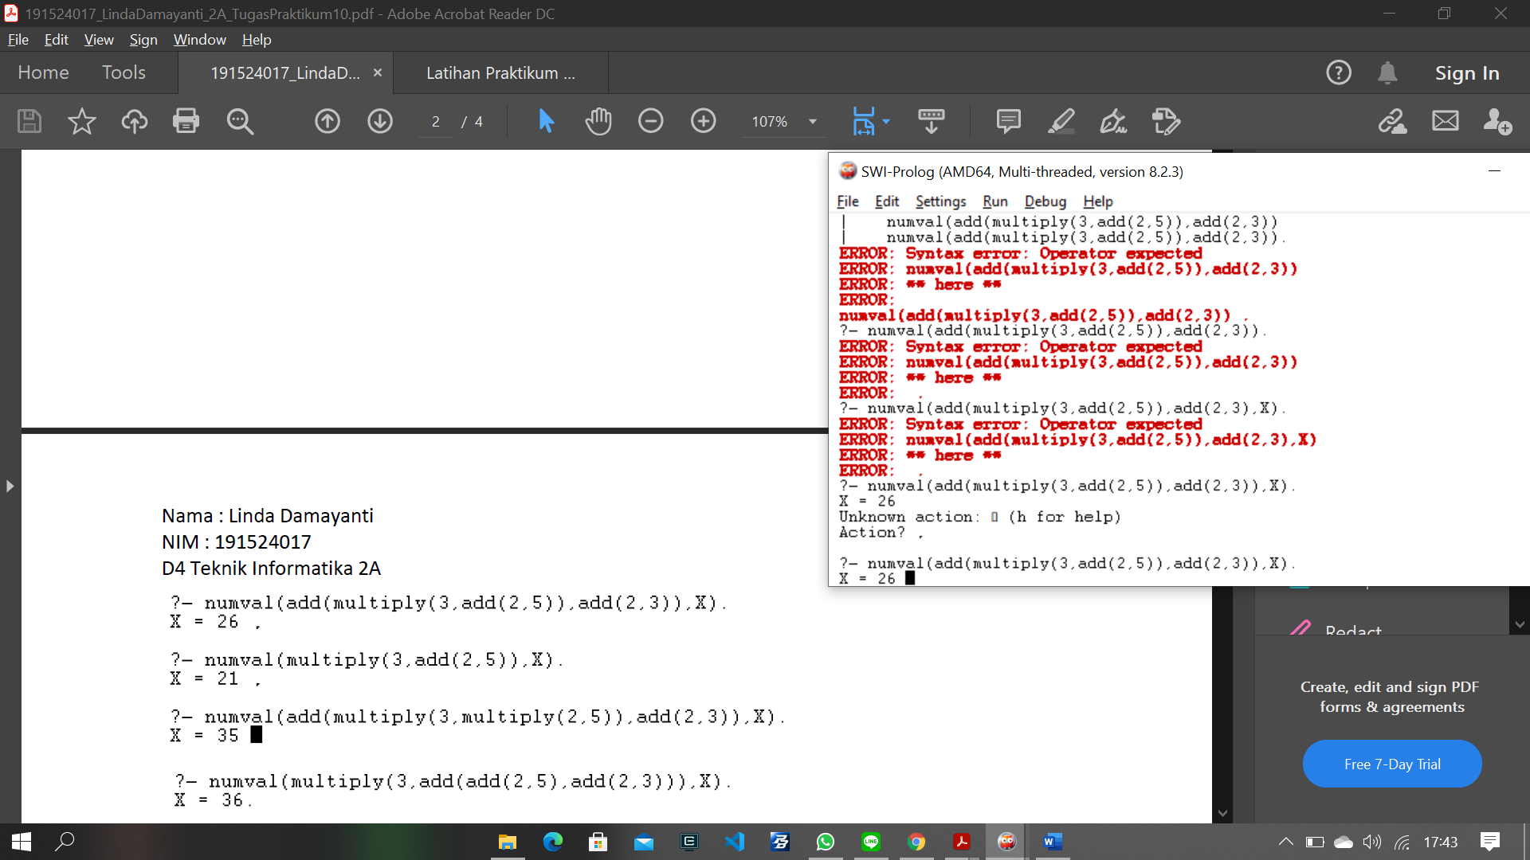

1. Source :

add([],_,[]).

add([X|Y],I,[X|Z]):-

append(Y,I,Z).

Output:

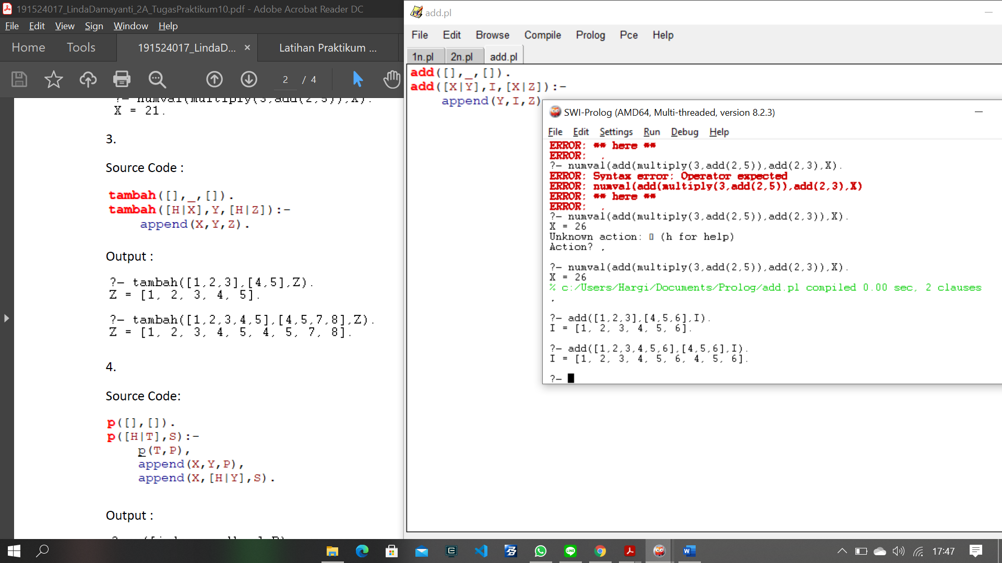

1. Source :

p([],[]).

p([I|J],K):-

p(J,M),

append(X,Y,M),

append(X,[I|Y],K).

Output :

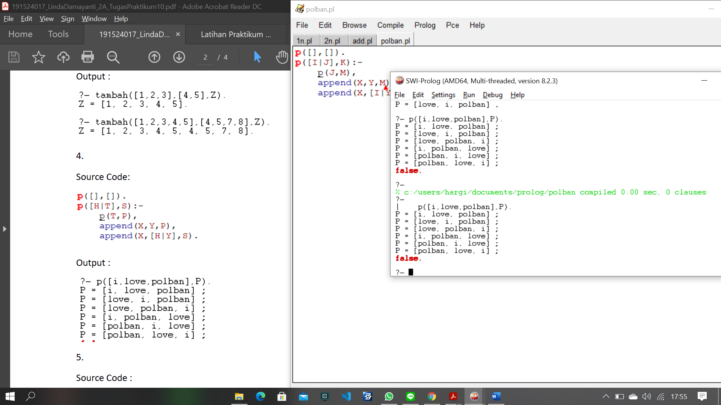

1. –
2. Source:

double([],[]).

double([X|Y],[X,X|Z]):-

double(Y,Z).

Output :

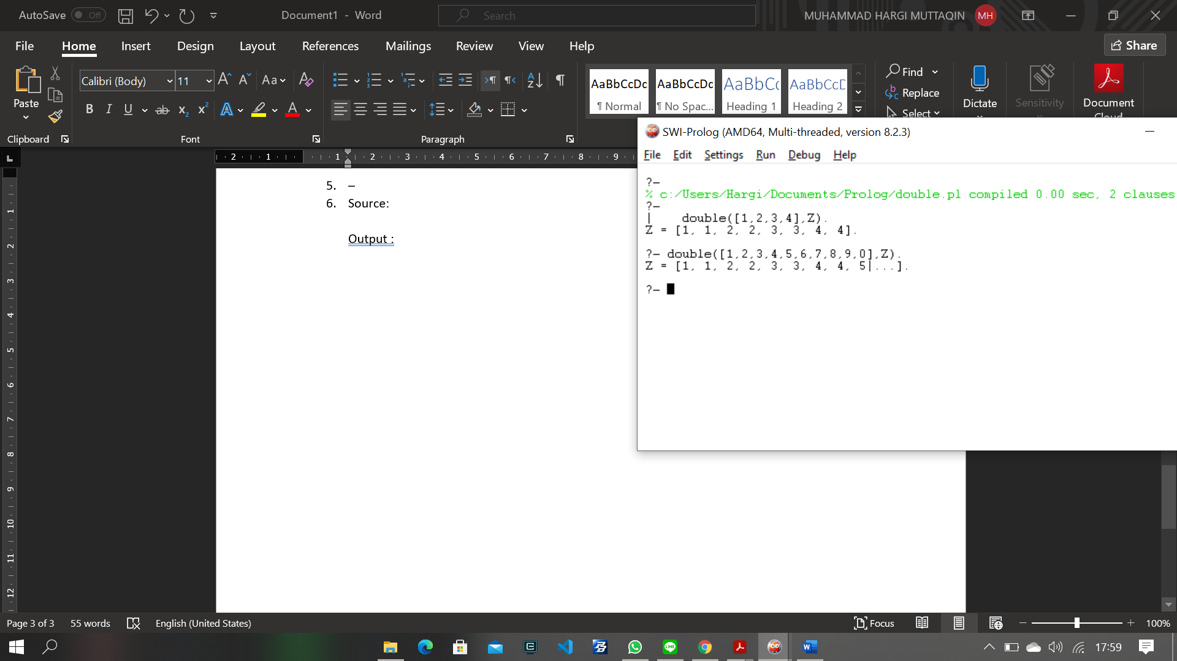

1. Source :

row(X,X,[X]).

row(X,Y,[X|Z]):-

X < Y,

I is X+1,

row(I,Y,Z).

Output :

